Data Mining Project Report



Submitted By:



# **Project**

Breast Cancer detection:

Worldwide, breast cancer is the most common type of cancer in women and the second highest in terms of mortality rates.Diagnosis of breast cancer is performed when an abnormal lump is found (from self-examination or x-ray) or a tiny speck of calcium is seen (on an x-ray). After a suspicious lump is found, the doctor will conduct a diagnosis to determine whether it is cancerous and, if so, whether it has spread to other parts of the body.

In this project a machine learning model is created for detecting the cancer. Features are computed from a digitized image of a fine needle aspirate (FNA) of a breast mass. They describe characteristics of the cell nuclei present in the image.n the 3-dimensional space is that described in: [K. P. Bennett and O. L. Mangasarian: "Robust Linear Programming Discrimination of Two Linearly Inseparable Sets", Optimization Methods and Software 1, 1992, 23-34].

# Required Models

* Logistic regression
* Random forests
* Naive Bayes
* Logistic regression is a supervised machine learning approach that focuses on classification. There are two types of linear regressions: simple linear regressions and multiple linear regressions. A logistic regression model is the result of a non- linear modification of a linear regression model.
* Random forests, also known as random decision forests, are a sort of approach for classification, regression, and other tasks that entails training a huge number of decision trees and then using the classes technique or mean prediction to output the class. The problem of decision trees overfitting their training set is addressed using random decision forests. To train tree learners, the random forest training strategy employs the classic approach of bootstrap aggregation, or bagging.
* The Naive Bayes technique is supervised learning tool for dealing with classification problems that is developed on the Bayes theorem. The Naive Bayes Classifier is simple yet efficient classification strategy that can help you quickly and effectively develop machine learning models. It's a probabilistic classifier, meaning it predicts outcomes based on the probability of an object. The Nave Bayes Algorithm is used in spam filtering, sentiment analysis, and article classification.

# Data set

* For this project breast cancer dataset is used which is obtained from the University of Wisconsin Hospitals, Madison from Dr. William H. Wolberg.

# Related work

* To predict new output values, ML algorithms use historic data as input. The goal of this study is to determine which characteristics are most effective in predicting whether a cancer is malignant or benign, as well as any overarching tendencies that may aid with model and hyper framework selection. The aim is to figure out if the carcinoma is cancerous or not. The supervised learning classification algorithm is used as a result. In Machine Learning, we've picked three main types of classification algorithms. To get the highest accuracy, we applied supervised learning algorithms to forecast breast cancer detection data. In this sort of machine learning, data scientists provide algorithms with labeled training data and specify the variables they want the software to explore for relationships between. The algorithm's input as well as output are both provided.

Rationales

* As part of this program, several machine learning algorithms for breast cancer diagnosis are being identified and evaluated. Logistic regression, Nave Bayes, and Random Forest were compared in this study. All the methods are thoroughly examined for output and correctness.

**Attribute Information:**

1) ID number 2) Diagnosis (M = malignant, B = benign) 3-32)

Ten real-valued features are computed for each cell nucleus:

1) radius (mean of distances from center to points on the perimeter)  
2) texture (standard deviation of gray-scale values)  
3) perimeter  
4) area  
5) smoothness (local variation in radius lengths)  
6) compactness (perimeter^2 / area - 1.0)  
7) concavity (severity of concave portions of the contour)  
8) concave points (number of concave portions of the contour)  
9) symmetry  
10) fractal dimension ("coastline approximation" - 1)

The mean, standard error and "worst" or largest (mean of the three largest values) of these features were computed for each image, resulting in 30 features. For instance, field 3 is Mean Radius, field 13 is Radius SE, field 23 is Worst Radius.

B 62.7

M 37.3

Name: diagnosis, dtype: float64

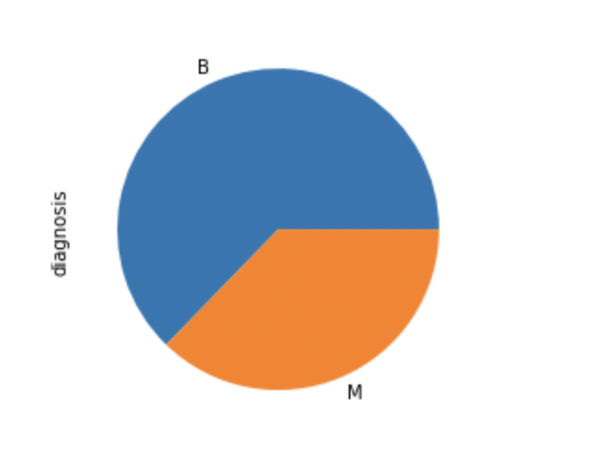

63% of data is Benign and 37% of data is malignant.

Distribution of Numeric Features in Univariant Analysis:

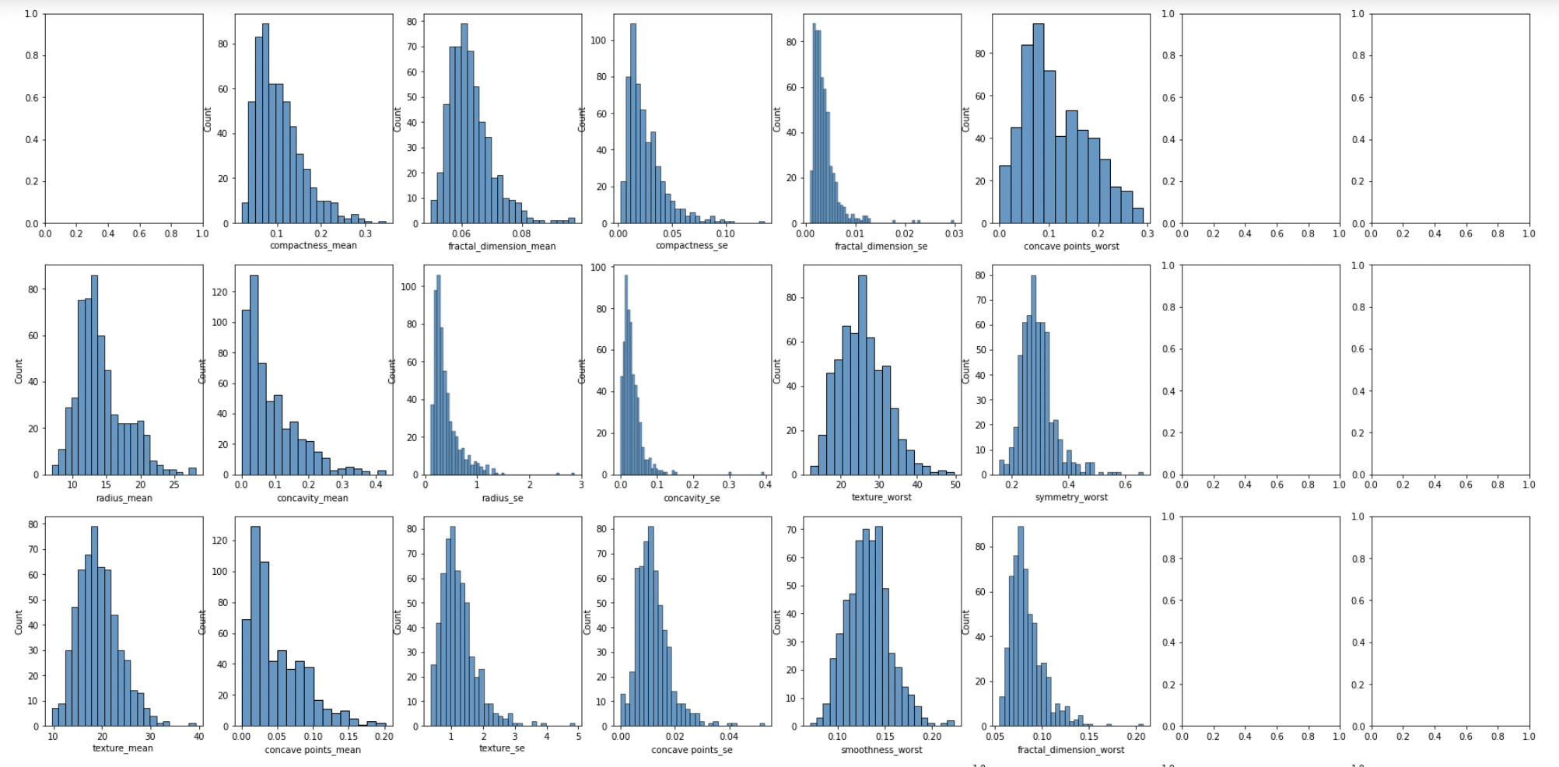 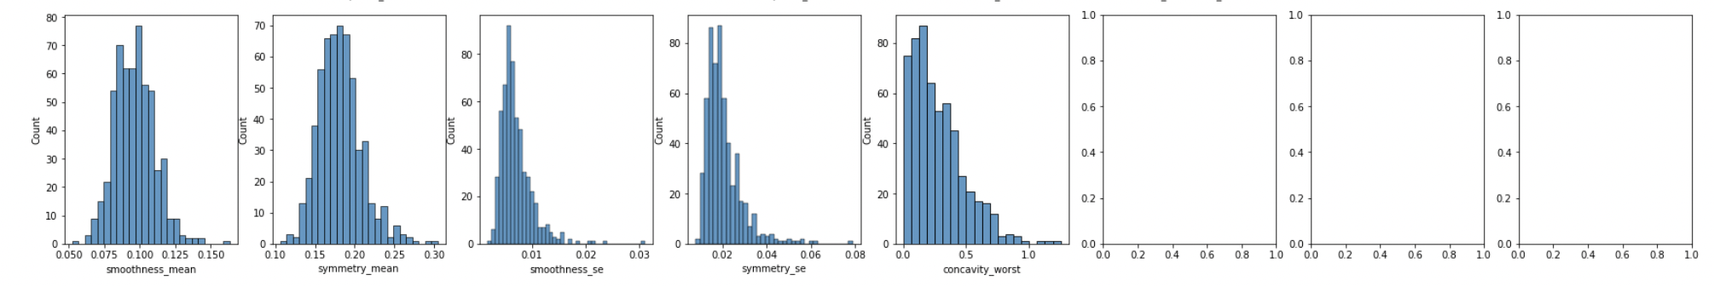

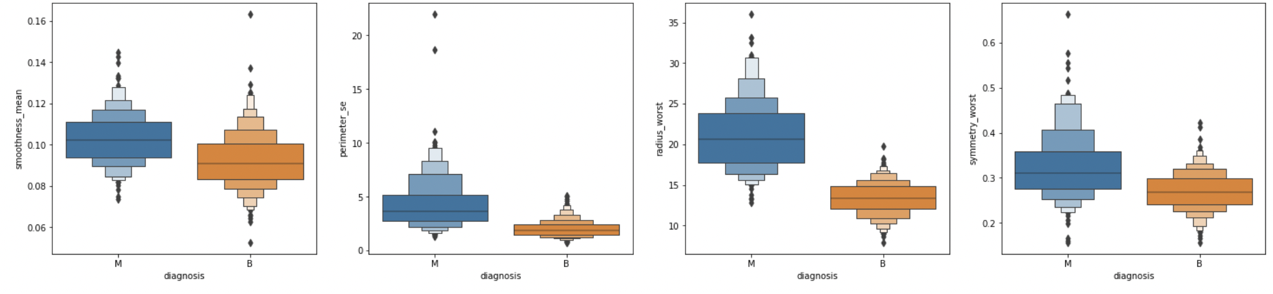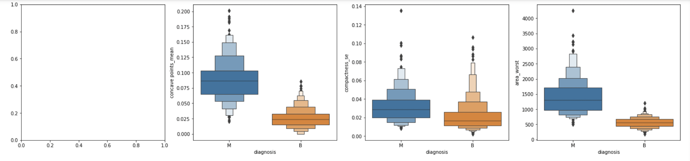 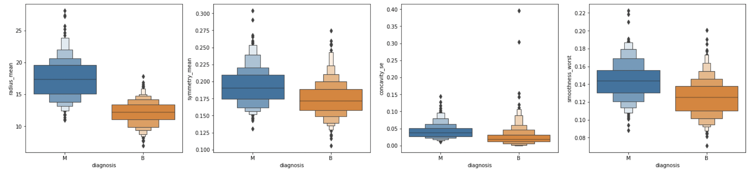 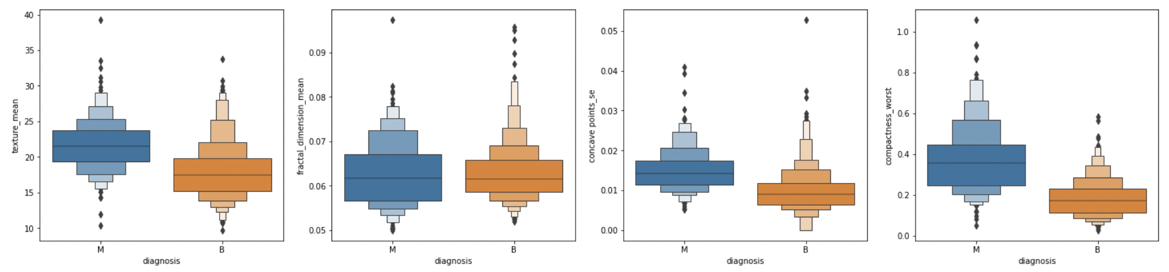 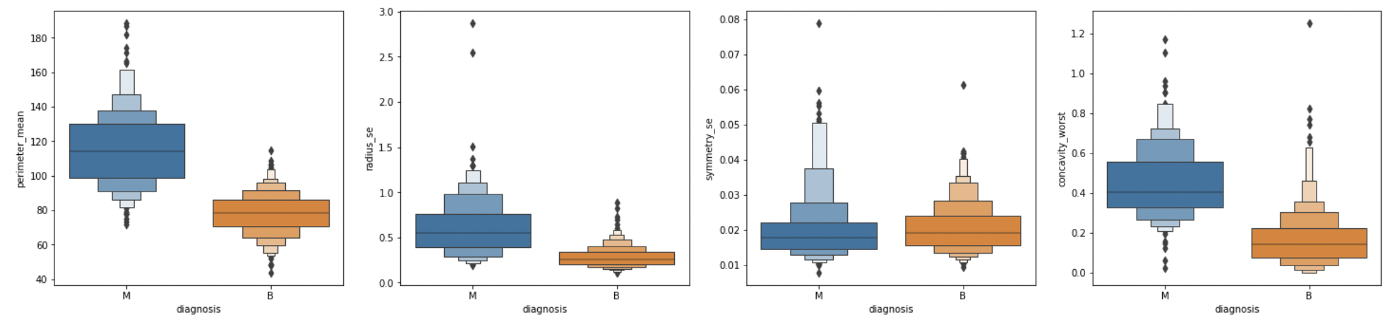 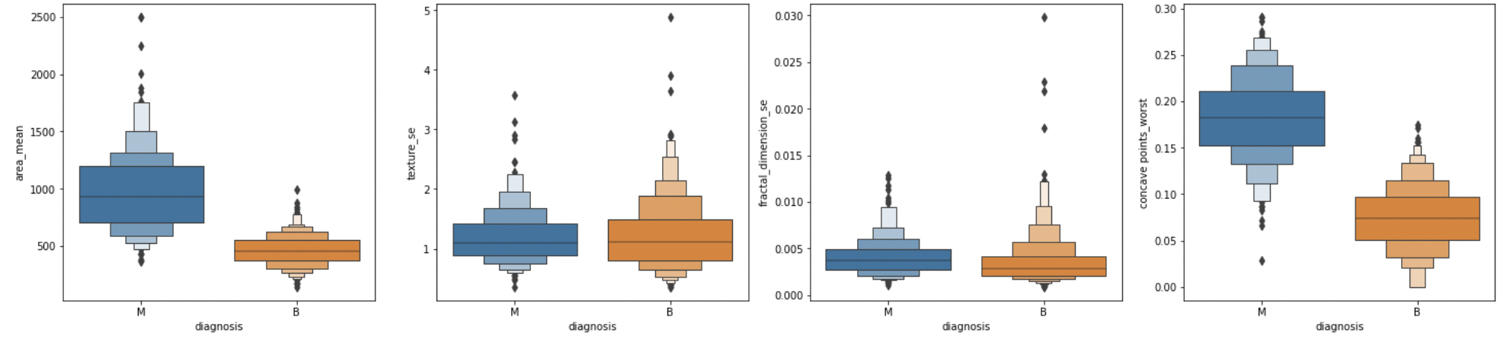 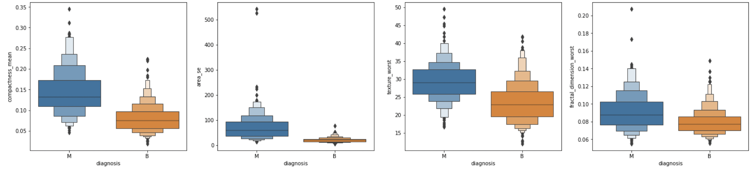 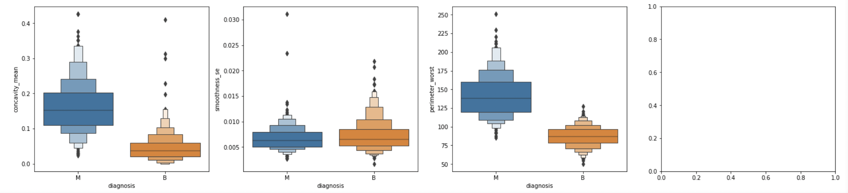

Higher the feature value higher the chances of malignant tumor

Correlation Matrix:

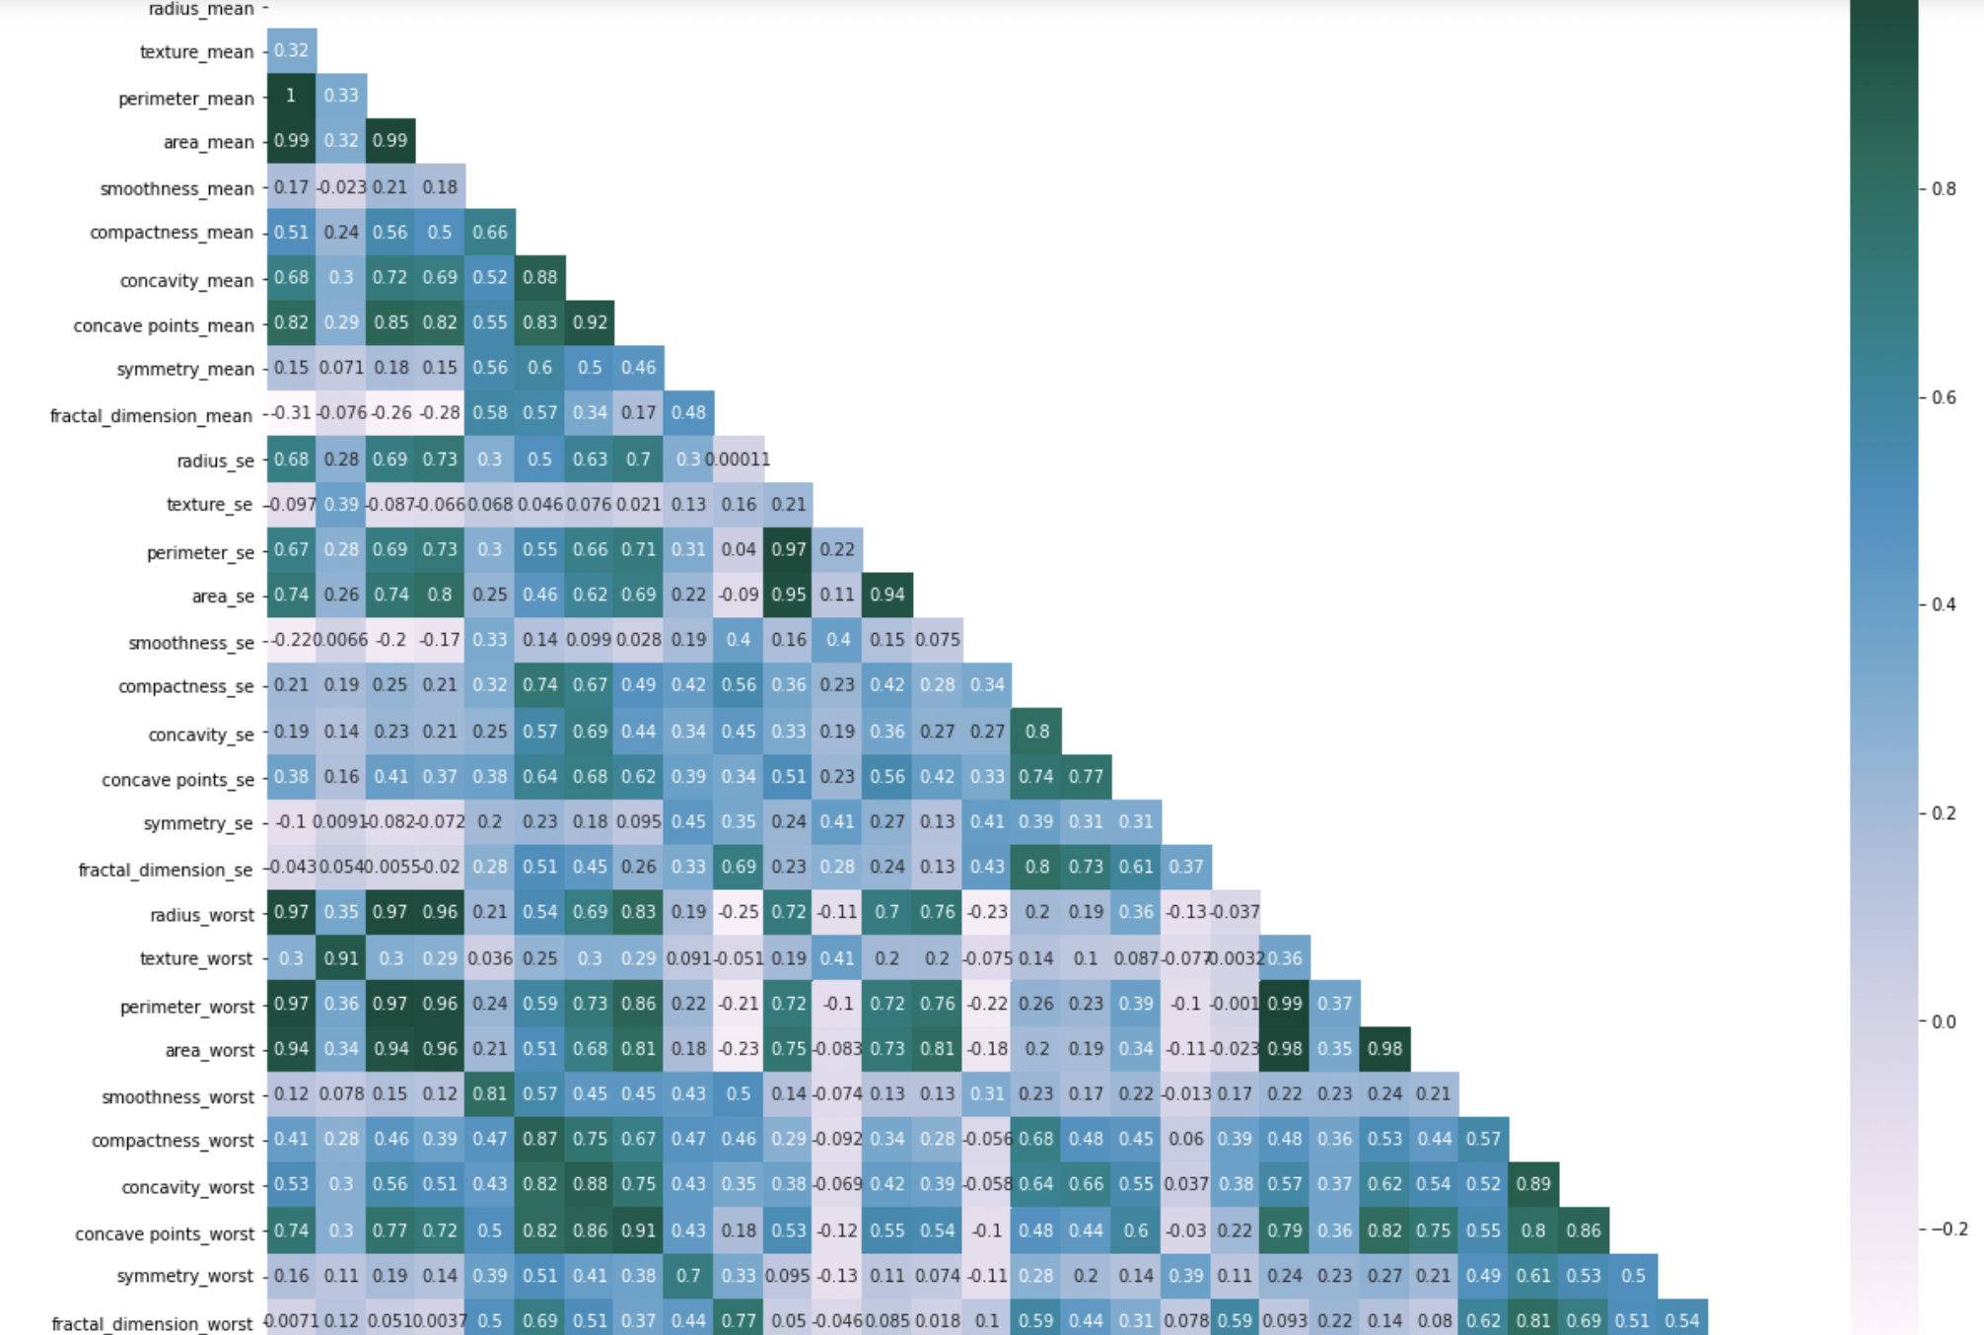

**Dropping the highly corelated features  
From the above plot we can see  
radius mean is highly corelated with area_worst,perimeter_worst,radius_worst,area_mean,perimeter_mean  
radius_se is highly corelated with perimeter_se and area_se**

Model Building with logistic Regression and Logistic Regression with PCA:

Evaluating train data in logistic regression

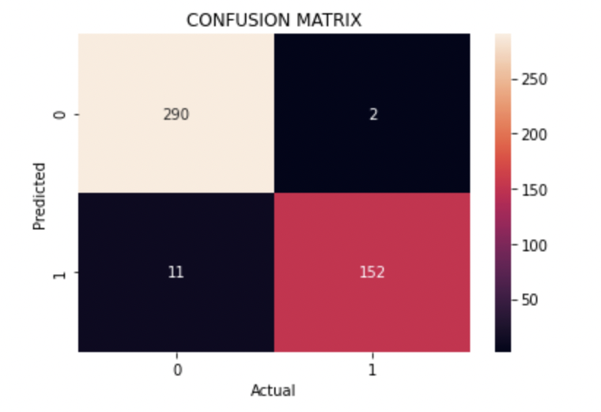

*******************************************************

precision recall f1-score support

0 0.96 0.99 0.98 292

1 0.99 0.93 0.96 163

accuracy 0.97 455

macro avg 0.98 0.96 0.97 455

weighted avg 0.97 0.97 0.97 455

Evaluating test data:

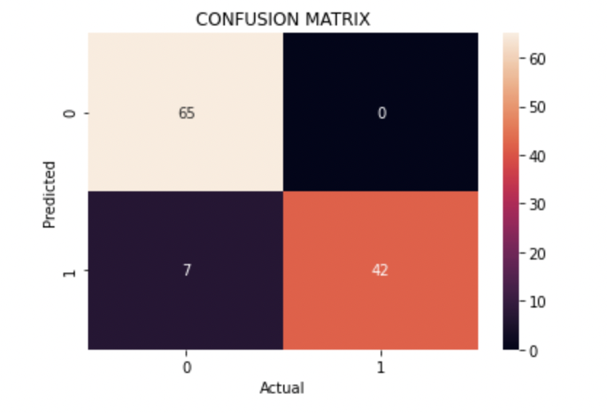

*******************************************************

precision recall f1-score support

0 0.90 1.00 0.95 65

1 1.00 0.86 0.92 49

accuracy 0.94 114

macro avg 0.95 0.93 0.94 114

weighted avg 0.94 0.94 0.94 114

Top 10 most important features which affect the tpe of cancer are

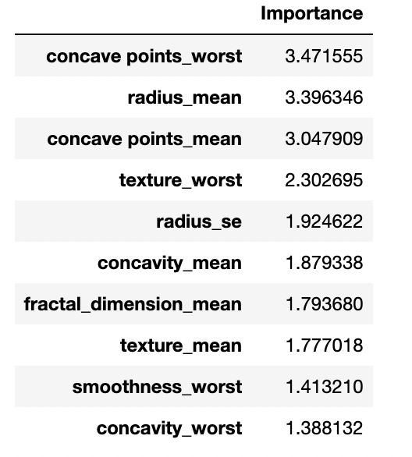

Feature Importance Plot for logistic regression

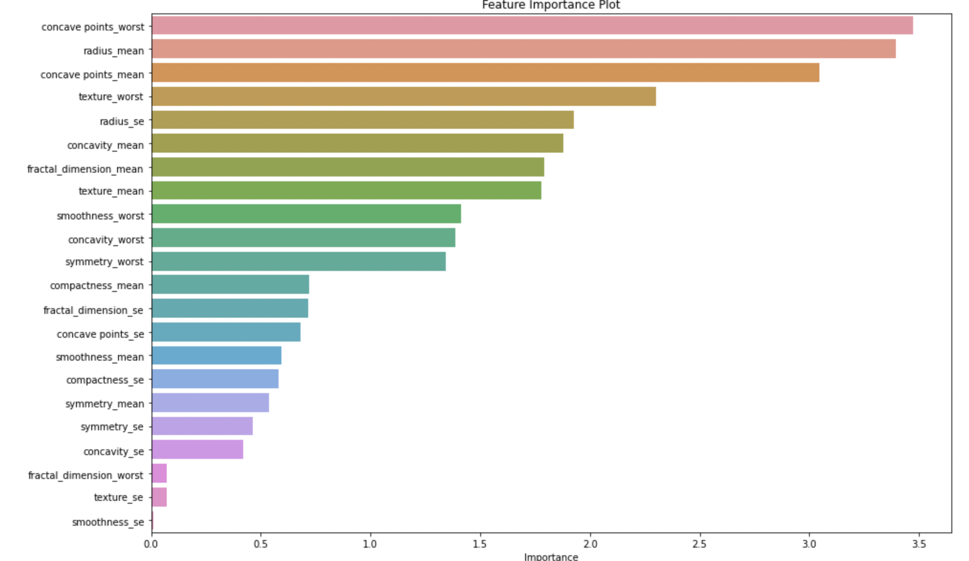

Bar Container Object of 22 objects:

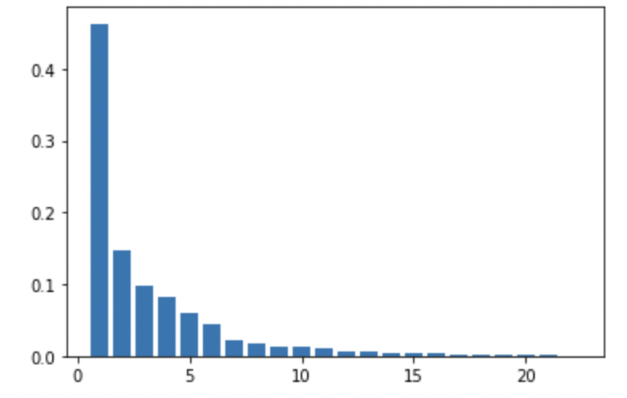

Variance cumulative plot for variance and Number features:

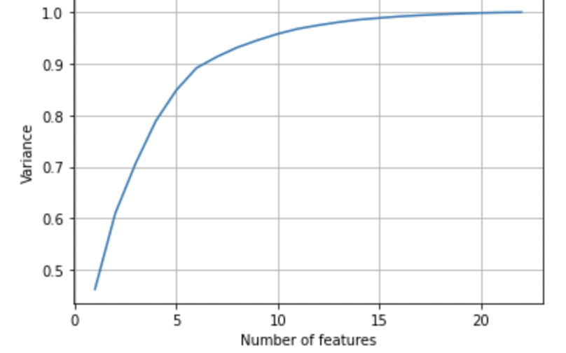

From the above plot we can see 10 parameters are requiried for this model

Logistic Regression with PCA:

Evaluating train data

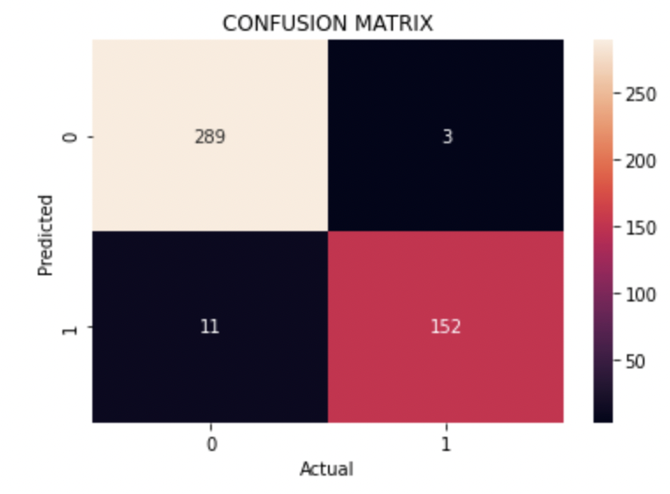

*******************************************************

precision recall f1-score support

0 0.96 0.99 0.98 292

1 0.98 0.93 0.96 163

accuracy 0.97 455

macro avg 0.97 0.96 0.97 455

weighted avg 0.97 0.97 0.97 455

Evaluating Test data:

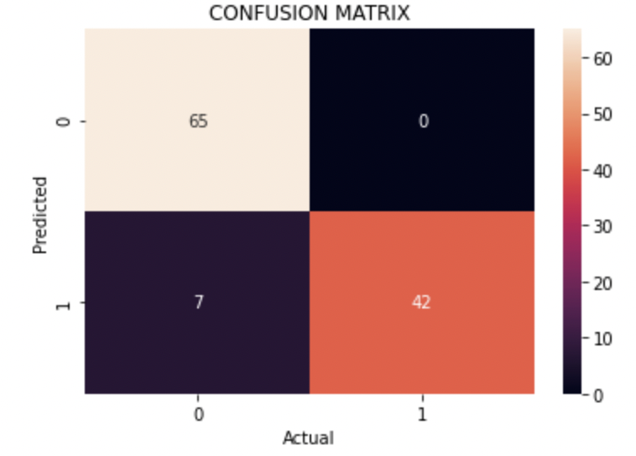

*******************************************************

precision recall f1-score support

0 0.90 1.00 0.95 65

1 1.00 0.86 0.92 49

accuracy 0.94 114

macro avg 0.95 0.93 0.94 114

weighted avg 0.94 0.94 0.94 114

# Conclusion

* Breast cancer prediction is known by comparing the metrics of all the models by their accuracy.

Random Decision Tree:

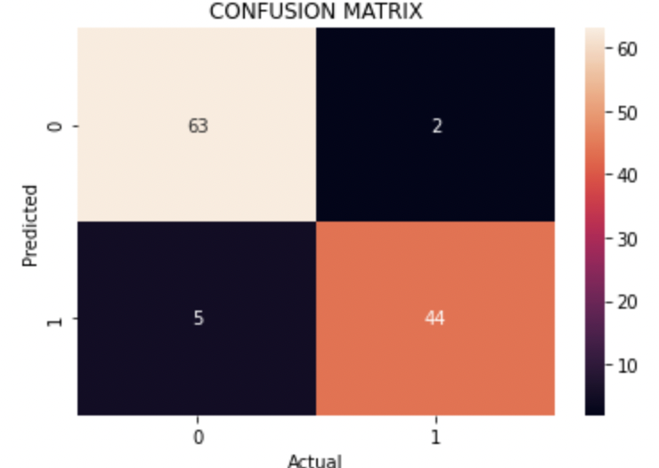

*******************************************************

precision recall f1-score support

0 0.93 0.97 0.95 65

1 0.96 0.90 0.93 49

accuracy 0.94 114

macro avg 0.94 0.93 0.94 114

weighted avg 0.94 0.94 0.94 114

Random forest:

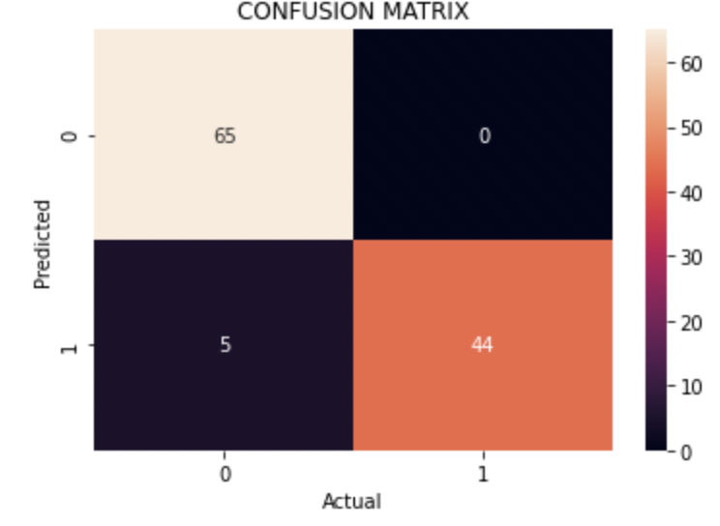

*******************************************************

precision recall f1-score support

0 0.93 1.00 0.96 65

1 1.00 0.90 0.95 49

accuracy 0.96 114

macro avg 0.96 0.95 0.95 114

weighted avg 0.96 0.96 0.96 114

KNN:

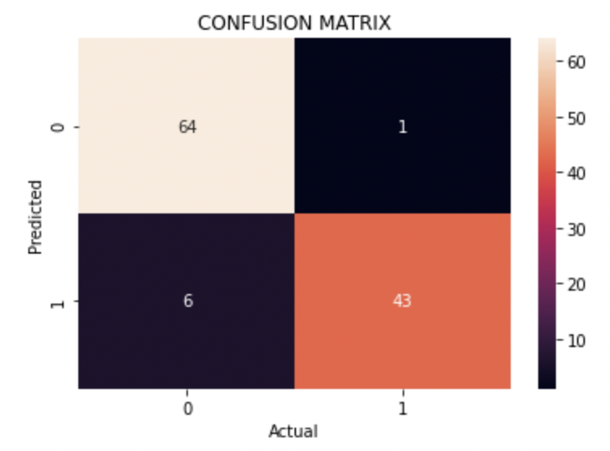

*******************************************************

precision recall f1-score support

0 0.91 0.98 0.95 65

1 0.98 0.88 0.92 49

accuracy 0.94 114

macro avg 0.95 0.93 0.94 114

weighted avg 0.94 0.94 0.94 114

SVM:

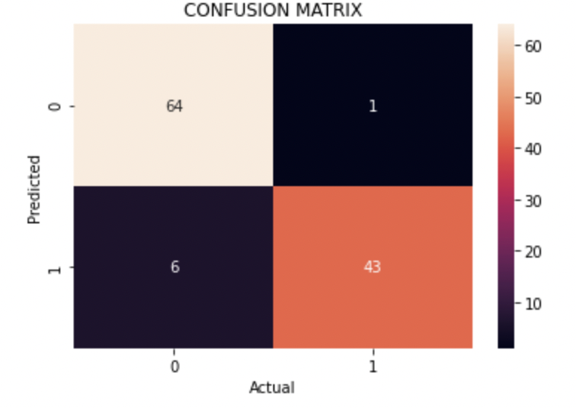

*******************************************************

precision recall f1-score support

0 0.91 0.98 0.95 65

1 0.98 0.88 0.92 49

accuracy 0.94 114

macro avg 0.95 0.93 0.94 114

weighted avg 0.94 0.94 0.94 114

**CONCLUSION:**

Compare the metrics for all the models

Type *Markdown* and LaTeX: 𝛼2